THERMODYNAMICS
(Enthalpy, Entropy and Free Energy)
AAIMS Workshop 2022

General Notes:

∆H˚

S˚

∆G˚

Multiple Choice:

1. Based on the following reaction, the information provided and your knowledge of thermodynamic properties, which statement is correct regarding the reaction?
Heat + CaCO₃(s) → CaO(s) + CO₂(g)

 | ∆H˚ | ∆S˚
A) | Negative | Positive
B) | Positive | Negative
C) | Negative | Negative
D) | Positive | Positive

2. Which of the following systems is expected to have the greatest increase in entropy?
A) Na⁺(g) + Cl–(g) → NaCl(s)
B) SO₂(g) + H₂O(l) → H₂SO₃(aq)
C) NH₄Cl(s) → HCl(g) + NH₃(g)
D) CO₂(g) → CO(g) + $\frac{1}{2}$O₂(g)

3. For which of the following reaction are ∆H˚rxn and ∆G˚rxn about the same?
- 4Fe(s) + 3O2(g) → Fe2O3(s)
- 2Na(s) + 2H2O(l) → 2Na+(aq) + 2OH-(aq) + H2(g)
- N2O4(g) → 2NO2(g)
- Fe2O3(s) + 2Al(s) → Al2O3(s) + 2Fe(s)

4. CH₃OH(g) → CO(g) + 2H₂(g) ΔH˚= +91 kJ mol-1

The reaction takes place in a rigid, insulated vessel that is initially at 600 K. At this temperature the reaction represented above goes left to right, essentially to completion.

What can be inferred about the ∆S˚ for the reaction at 600 K?

- ∆S˚ must be positive, since the reaction is thermodynamically unfavorable at 600 K.
- ∆S˚ must be negative, since there are more moles of products than reactants.
- ∆S˚ must be positive, since ∆G˚ is negative and ∆H˚ is positive.
- ∆S˚ must be negative, since ∆G˚ is positive and ∆H˚ is positive.

- For the reaction
H2O(g) → H2(g) + 1/2 O2(g)
∆H° is +242 kJ mol-1and ∆S° is +45 J mol-1 K -1.

- ∆G˚ is always positive.
- ∆G˚ is always negative.
- ∆G˚ is negative at low temperature.
- ∆G˚ is negative at high temperature.

- The reaction
N₂(g) + 3 H₂(g) 2 NH₃(g)
is thermodynamically spontaneous at 298 K, but becomes nonspontaneous at higher temperatures. Which of the following is true at 298 K?
A) ∆G, ∆H, and ∆S are all positive.
B) ∆G, ∆H, and ∆S are all negative.
C) ∆G and ∆H are negative, but ∆S is positive.
D) ∆G and ∆S are negative, but ∆H is positive.

Free Response:

1. In thermodynamic terms a reaction can be driven by enthalpy, entropy or both. After the two solids, Ba(OH)₂·8H₂O(s) and NH₄Cl(s), are mixed in a beaker the beaker feels cooler compared to room temperature. The chemical equation that describes the reaction are shown below.
Ba(OH)₂·8H₂O(s) + 2NH₄Cl(s) → 2NH₃(g) + 10H₂O(l) + BaCl₂(aq)
(a) Is ∆S˚ for the reaction positive, negative or zero? What evidence do you have to support your claim?

(b) Is ∆G˚ for the reaction positive, negative or zero? What evidence do you have to support your claim?

(c) Is this reaction driven by enthalpy or entropy or both? Justify your selection in terms of ∆G˚.

NaHCO₃(s) + HC₂H₃O₂(aq) NaC₂H₃O₂(aq) + H₂O(l) + CO₂(g)

2. A student designs an experiment to study the reaction between NaHCO₃ and HC₂H₃O₂. The reaction is represented by the equation above. The student places 2.24 g of NaHCO₃ in a flask and adds 60.0 mL of 0.875 M HC₂H₃O₂. The student observes the formation of bubbles, and that the flask gets cooler as the reaction proceeds.

(a) Identify the reaction represented above as an acid-base reaction, precipitation reaction, or redox reaction. Justify your answer.

(b) Based on the information above, identify the limiting reactant. Justify your answer with calculations.

(c) The student observes that the bubbling is rapid at the beginning of the reaction and gradually slows as the reaction continues. Explain this change in the reaction rate in terms of the collisions between reactant particles.

(d) In thermodynamic terms, a reaction can be driven by enthalpy, entropy, or both.
(i) Considering that the flask gets cooler as the reaction proceeds, what drives the chemical reaction between NaHCO₃(s) and HC₂H₃O₂(aq)? Answer by drawing a circle around one of the choices below.

Enthalpy only Entropy only Both enthalpy and entropy

(ii) Justify your selection in part (d)(i) in terms of ∆G˚.

(e) The HCO₃⁻ ion has three carbon-to-oxygen bonds. Two of the carbon-to-oxygen bonds have the same length and the third carbon-to-oxygen bond is longer than the other two. The hydrogen atom is bonded to one of the oxygen atoms. In the box below, draw a Lewis electron-dot diagram (or diagrams) for the HCO₃⁻ ion that is (are) consistent with the given information.

(f) A student prepares a solution containing equimolar amounts of NaC₂H₃O₂ and HC₂H₃O₂. The pH of the solution is measured to be 4.7. The student adds two drops of 3.0 M HNO₃(aq) and stirs the sample, observing that the pH remains at 4.7. Write a balanced, net-ionic equation for the reaction between HNO₃(aq) and the chemical species in the sample that is responsible for the pH remaining at 4.7.

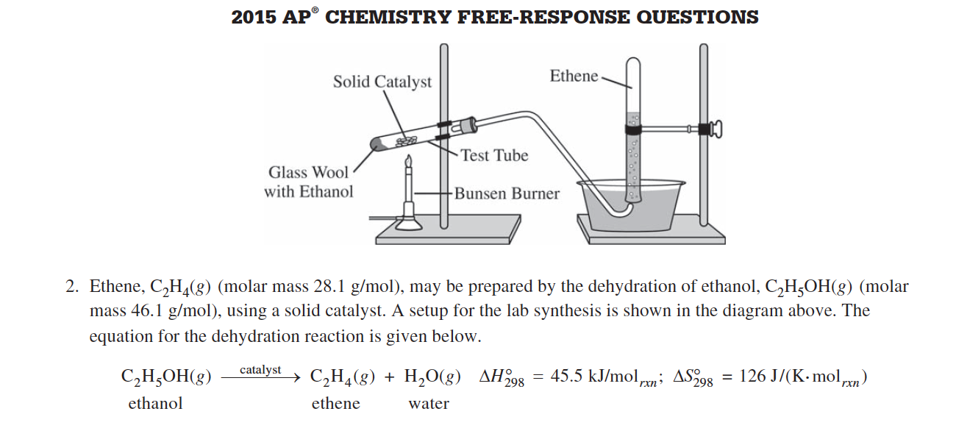

Because the dehydration reaction is not observed to occur at 298K, the student claims that the reaction has an equilibrium constant less than 1.00 at 298K.
(c) Do the thermodynamic data for the reaction support the student’s claim? Justify your answer, including a calculation of ∆G˚₂₉₈ for the reaction.

3. N₂(g) + 2 H₂(g) N₂H₄(g) ∆H˚₂₉₈ = +95.4 kJ mol⁻¹; ∆S˚₂₉₈ = —176 J K⁻¹ mol⁻¹

Answer the following questions about the reaction represented above using principles of thermodynamics.

(a) On the basis of the thermodynamic data given above, compare the sum of the bond strengths of the reactants to the sum of the bond strengths of the product. Justify your answer.

(b) Does the entropy change of the reaction support the reactants or the product as more dispersed? Justify your answer.

(c) For the reaction under the conditions specified, which is favored, the reactants or the product? Justify your answer.

(d) Explain how to determine the value of the equilibrium constant, K_{eq}, for the reaction. (Do not do any calculations.)

(e) Predict whether the value of the K_{eq}, for the reaction is greater than 1, equal to 1, or less than 1. Justify your answer.

4. The student reads in a reference text that NO(g) and NO₂(g) will react as represented by the equation below. Thermodynamic data for the reaction are given in the table below the equation.

NO(g) + NO₂(g) N₂O₃(g)

∆H˚₂₉₈ | ∆S˚₂₉₈ | ∆G˚₂₉₈
—40.4 kJ/mol_{rxn} | —138.5 J /(K·mol_{rxn}) | 0.87 kJ/mol_{rxn}

(b) The student begins with an equimolar mixture of NO(g) and NO₂(g) in a rigid reaction vessel and the mixture reaches equilibrium at 298K.
(i) Calculate the value of the equilibrium constant, K, for the reaction at 298K.

(ii) If both PNO and PNO₂ in the vessel are initially 1.0 atm, will PN₂O₃ at equilibrium be equal to 1.0 atm. Justify your answer.

(c) The student hypothesizes that increasing the temperature will increase the amount of N₂O₃(g) in the equilibrium mixture. Indicate whether you agree or disagree with the hypothesis. Justify your answer.

5.
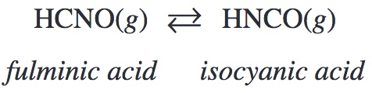

(b) Using the Lewis electron-dot diagrams of fulminic acid and isocyanic acid shown in the boxes above and the table of average bond enthalpies below, determine the value of ∆H° for the reaction of HCNO(g) to form HNCO(g).
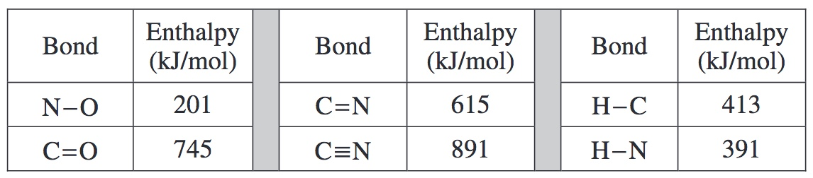

(c) A student claims that ∆S° for the reaction is close to zero. Explain why the student’s claim is accurate.

(d) Which species, fulminic acid (HCNO) or isocyanic acid (HNCO), is present in higher concentration at equilibrium at 298K? Justify your answer in terms of thermodynamic favorability and the equilibrium constant.

6. The reaction below is important in automobile catalytic converters

2CO(g) + 2NO(g) → N₂(g) + 2CO₂(g)

Compound | ∆H_{f}˚ (kJ mol⁻¹) | S˚(J mol⁻¹ K⁻¹) | ∆G_{f}˚(kJ mol⁻¹)
CO(g) | -110 | 198 | ?
NO(g) | +91.3 | 211 | 87.6
N₂(g) | 0 | 192 | 0
CO₂(g) | -393.5 | 214 | -394.4
C(s) | 0 | 5.7 | 0
O₂(g) | 0 | 205 | 0

(a) Calculate ∆H˚_{rxn}, ∆S˚_{rxn}, and ∆G˚_{rxn} for the reaction above at 298 K.

(b) Calculate K_{eq} for the reaction at 298 K.

(c) For the reaction, how is the value of the standard free energy, ∆G˚, and the thermodynamic favorability of the reaction affected by an increase in temperature? You may wish to use a mathematical relationship to help in your explanation.

7. Cl₂(g) + 3 F₂(g) 2 ClF₃(g)

ClF₃ can be prepared by the reaction represented by the equation above. For ClF₃ the standard enthalpy of formation, ∆H˚_{f} is —163.2 kJ/mol and the standard free energy of formation, ∆G˚_{f} is —123.0 kJ/mol.

(a) Calculate the value of the equilibrium constant for the reaction at 298K.

(b) Calculate the standard entropy change, ∆S˚, for the reaction at 298K.

(c) If ClF₃ were produced as a liquid rather than as a gas, how would the sign and magnitude of ∆S˚ for the reaction be affected? Explain.

(d) At 298 K the absolute entropies of Cl₂(g) and ClF₃(g) are 222.96 joules per mole-Kelvin and 281.50 joules per mole-Kelvin, respectively.

(i) Account for the larger entropy of ClF₃(g) relative to that of Cl₂(g).

(ii) Calculate the value of the absolute entropy of F₂(g) at 298K.

