KINETICS
AAIMS Workshop 2022

1. The following initial rate data were collected for the reaction

BrO3–(aq) + 5Br–(aq) + 6H+(aq) → 3Br2(aq) + 3H2O(l)
at 25 ˚C.

Exp. # [BrO3–] [Br–] [H+] rate of disappearance
of BrO3– $\left(\frac{M}{s}\right)$
1 0.200 M 0.100 M 6.31 x 10–3 6.37 x 10–6
2 0.300 M 0.100 M 6.31 x 10–3 9.56 x 10–6
3 0.500 M 0.200 M 6.31 x 10–3 3.18 x 10–5
4 0.500 M 0.200 M 1.00 x 10–2 8.00 x 10–5

- Determine the reaction order for
    - BrO3–

    - Br–

    - H+

b) Write the specific rate law for the reaction.

c) Determine the rate constant for the reaction (include units).

d) When a 5th run used [BrO3–] = 0.500 M and the [Br–]= 0.400 M the rate of disappearance of BrO3– was 8.00 x 10–6 M s–1. Calculate the pH of the solution for this run.

2. The following data is for the decomposition of NOBr to Br2 and NO at a particular temperature.

Time (seconds) | 0 | 2.0 | 4.0 | 6 | 8 | 10
[NOBr] (mol/L) | 0.0100 | 0.0071 | 0.0055 | 0.0045 | 0.0038 | 0.0033

Describe a graphical method that could be used to determine the order of the reaction and the rate constant for the reaction.

3. The following data was collected at a specific temperature for the reaction
2NO(g) + Cl2(g) → 2NOCl(g)

Experiment | [NO] | [Cl2] | Initial Rate (M s-1)
1 | 0.115 M | 0.263 M | 6.74 x 10-2
2 | 0.200 M | 0.264 M | 1.17 x 10-1
3 | 0.065 M | 0.389 M | 5.63 x 10-2

- Determine the order of the reaction with respect to NO and Cl2. (Show your work clearly)

- Write the differential rate law for this reaction.

- What is the magnitude and the units of the rate constant?

- The initial rate listed in the table is in terms of the disappearance of Cl2. For Experiment 1 calculate the initial rate of appearance of NOCl.

- A student proposed the for following 2-step mechanism. Do you agree with the student that this mechanism is supported by the rate law? Explain.
Step 1: NO + Cl₂ NOCl + Cl (slow)
Step 2: NO + Cl NOCl (fast)

- List two factors that are important for collisions between reactant molecules to be effective. Briefly, explain why all collisions between reactant molecules do not lead to a chemical reaction.

4. a) The diagram to the right shows the energy pathway for the reaction  O3(g) + NO(g) → NO2(g) + O2(g)  Clearly label the following directly on the diagram  - The activation energy, Ea, for the forward reaction;  ii) The enthalpy change, ∆H, for the reaction | 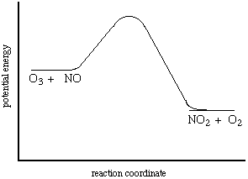
5. Data for the chemical reaction 2A → B + C were collected by measuring the concentration of A over time. The following graphs were generated from analysis of the data.

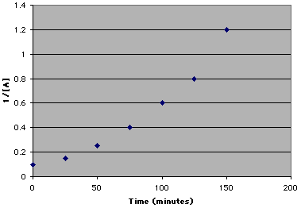 | 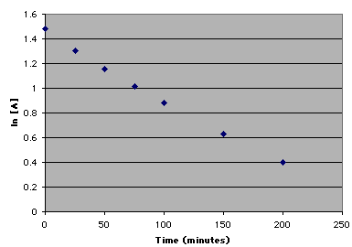

Using the information in the graphs above, answer the following questions.

- Write the rate law expression (differential form) for the reaction. Justify your answer.

- Describe how to determine the value of the rate constant for the reaction.

6. When a catalyst is added to a solution of HCOOH(aq), the reaction represented by the following equation occurs.
HCOOH(aq) H₂(g) + CO₂(g)

(i) Is the reaction a redox reaction? Justify your answer.

(ii) After the reaction has proceeded for several minutes, does the amount of catalyst increase, decrease, or remain the same? Justify your answer.

7. Blue food coloring can be oxidized by household bleach (which contains OCl⁻ ) to form colorless products, as represented by the equation.

Na₂C₃₇H₃₄N₂S₃O₉ + OCl⁻ → products blue colorless

A student used a spectrophotometer set at a wavelength of 635 nm to study the absorbance of the food coloring over time during the bleaching process. In the study, bleach is present in large excess so that the concentration of OCl⁻ is essentially constant throughout the reaction. The student used data from the study to generate the graphs below.
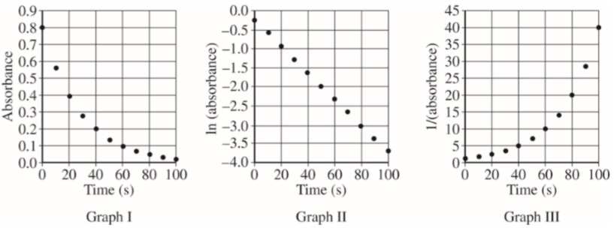

- Based on the graphs above, what is the order of the reaction with respect to the blue food coloring?

- The reaction is known to be first order with respect to bleach. In a second experiment, the student prepares solutions of food coloring and bleach with concentrations that differ from those used in the first experiment. When the solutions are combined, the student observes that the reaction mixture reaches an absorbance near zero too rapidly. In order to correct the problem, the student proposes the following three possible modifications to the experiment.
• Increasing the temperature
• Increasing the concentration of the food coloring
• Increasing the concentration of the bleach
Circle the one proposed modification above that could correct the problem and explain how that modification increases the time for the reaction mixture to reach an absorbance near zero.

- In another experiment, a student wishes to study the oxidation of red food coloring with bleach. How would the student need to modify the original experimental procedure to determine the order of the reaction with respect to the red food coloring?

8. HBPB⁺, the acidified form of bromophenol blue, BPB, is yellow and has a strong absorption peak at a wavelength of 440 nm. HBPB⁺ reacts with hydroxide ions according to the equation,
HBPB⁺(aq)+OH⁻(aq)⇄BPB(aq)+H₂O(l)
yellow blue

producing water and BPB, which is blue and has a strong absorption peak at a wavelength of 590 nm.

a) Write the Keq expression for the equilibrium reaction above.

The absorption spectra of an equilibrium mixture of HBPB⁺(aq) and BPB(aq) collected at two different temperatures, are shown in the diagram below.

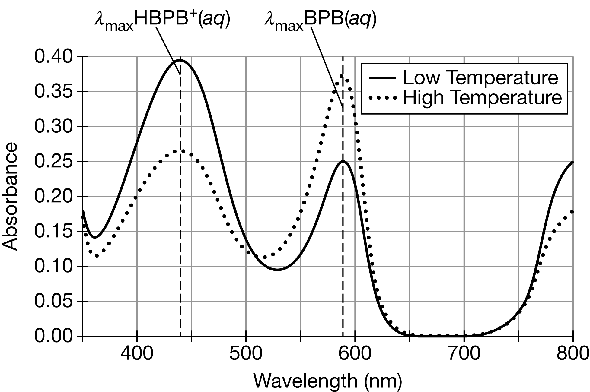
(b) At which wavelength, 350 nm or 440 nm, are photons with the higher energy absorbed? Justify your answer.

(c) Based on the diagram above, is the forward reaction endothermic or exothermic? Justify your answer in terms of Le Châtelier’s principle.

A calibration plot of the absorbance at wavelength 590 nm versus the concentration of BPB is shown in the graph below
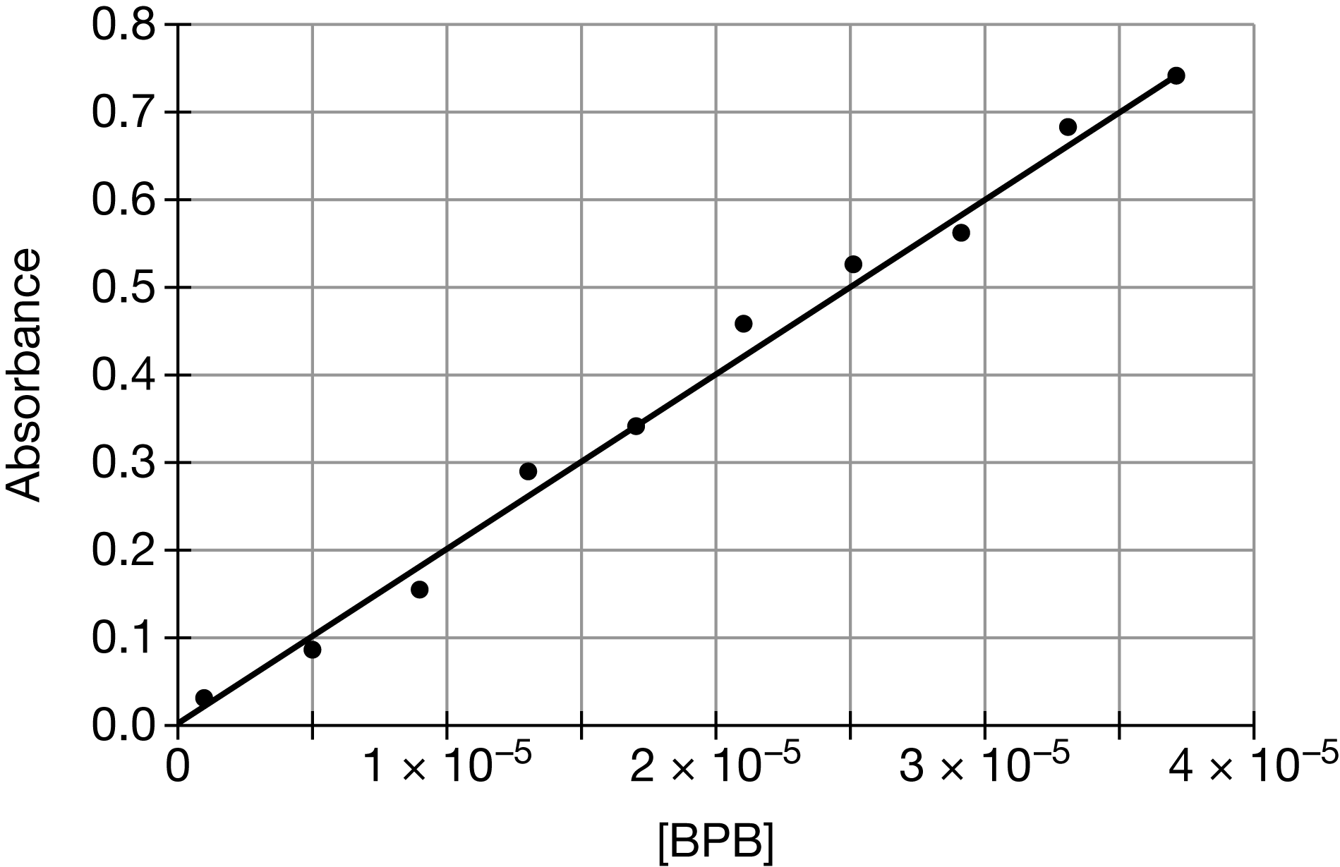

(d) Based on the best-fit line shown in the graph, what is the approximate absorbance for a solution in which [BPB]=2.0×10⁻⁵ M ?

(e) A student measures the absorbance of a solution of BPB of unknown concentration, in order to determine the [BPB] in the solution using the calibration plot above. If water remains in the cuvette prior to being filled with the solution, how will the estimated molarity compare to the actual [BPB] in the solution? Explain your reasoning.

Over time, BPB converts to a colorless molecule in the presence of OH⁻ ions. To study the rate of the reaction, the student recorded the absorbance of the BPB solution at 590 nm in a 0.10 M NaOH solution. The temperature and [OH⁻] remain constant throughout the reaction. The results are summarized in the table below.

Time (hr) | Absorbance
0 | 0.80
0.50 | 0.56
1.00 | 0.40
1.50 | 0.28
2.00 | 0.20
2.50 | 0.15
3.00 | 0.10

(f) Determine the half-life of the reaction. Include units with your answer.

(g) Explain how the absorbance and time data are consistent with a process that is first order with respect to BPB.

(h) Based on the data collected in this experiment, what is the time required for 75% of BPB to react? Justify your answer.

A second trial is conducted at the same constant temperature, but with [OH⁻] changed to 0.40 M. The observed half-life of the reaction is shorter than for the first trial when [OH⁻] was 0.10 M.

(i) Explain, in term of particle collisions, why the half-life of the reaction decreases when [OH⁻] is changed from 0.10 M to 0.40 M.

(j) When [OH⁻] is changed from 0.10 M to 0.40 M, does the magnitude of ΔH°_{rxn}, the enthalpy change of the reaction, increase, decrease, or stay the same? Justify your answer.

In order to prepare the 0.100 M solution of NaOH(aq), a student follows a procedure with the following steps.
- Step 1: Measure out 40.0 g of NaOH(s).
- Step 2: Add the NaOH(s) to a 1000.0 mL volumetric flask that is half-filled with distilled water.
- Step 3: Add enough distilled water to bring the volume up to the line on the flask.
(k) The chemical quantities used in the procedure does NOT produce 0.100 M NaOH(aq). Describe specifically how they should be changed, in order to produce 0.100 M NaOH(aq).

(l) Another student is preparing a 0.100 M NaOH solution using the correct chemical quantities, but notices that some solid remains at the bottom of the volumetric flask. Describe an action that the student should take to ensure that the remaining solid dissolves.

(m) When making the solution above, the student notices that the temperature increases when dissolving NaOH(s) in water. In a separate experiment, the student dissolves 1.0 mol of NaOH(s) in 1000. g each of two different solvents, X and Y. Assuming the enthalpy change is the same regardless of solvent, would the temperature change in solvent X be greater than, less than, or equal to the temperature change in solvent Y? Justify your answer. The specific heat capacities of solvent X and solvent Y are given in the table below.
Solvent | X | Y
Specific Heat Capacity (J/(g⋅°C)) | 2.53 | 2.91

